GOVERNMENT DEGREE COLLEGE, MUMMIDIVARAM,
Dr.B.R.AMBEDKAR KONASEEMA DISTRICT

DEPARTMENT OF COMPUTER SCIENCE

Extra-Curricular Activities
8) Activity : CYBER SMART CERTIFICATE
Date : 17-10-2023
Venue : II B.A Class Room
No of Students Participated : 58

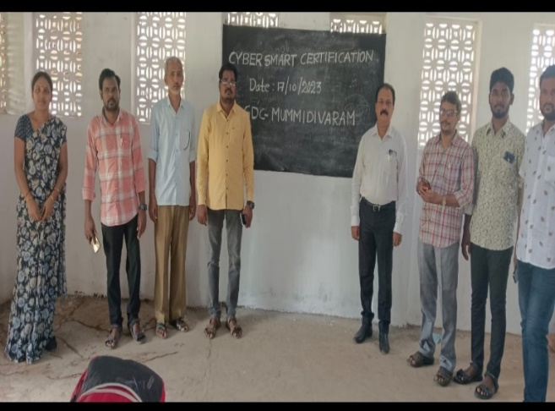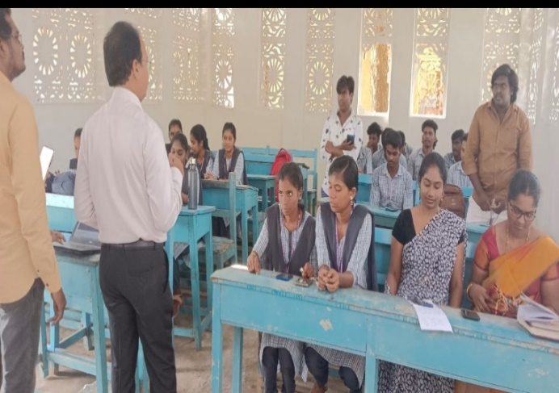
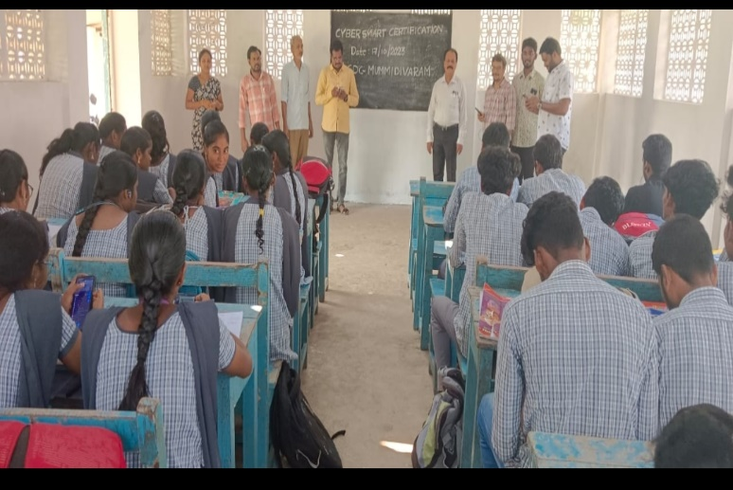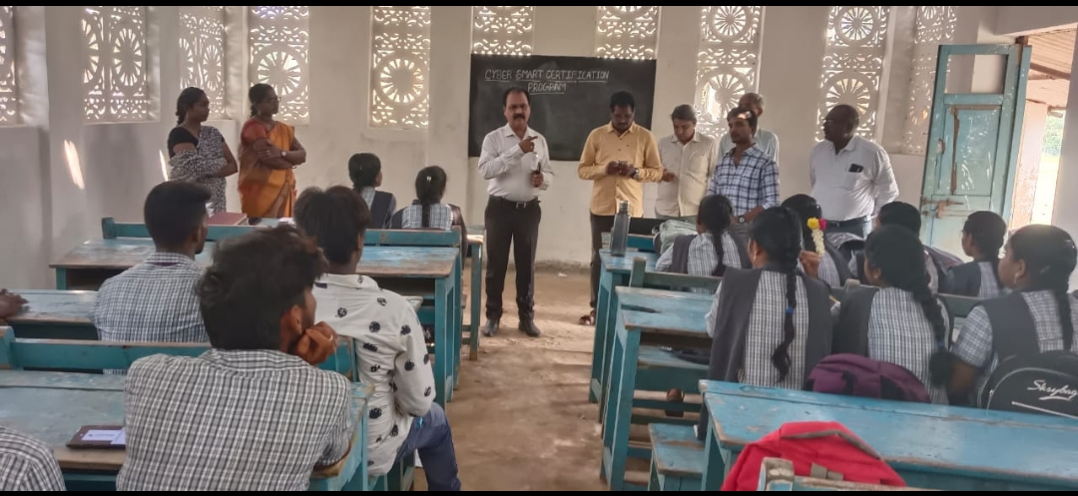
Awareness Program on Cyber Smart Certificate to all the three-years Students.

Signature of the Principal Signature of the Lecturer

