GOVERNMENT DEGREE COLLEGE, MUMMIDIVARAM,
Dr.B.R.AMBEDKAR KONASEEMA DISTRICT

DEPARTMENT OF COMPUTER SCIENCE

Extra-Curricular Activities
10) Activity : COMPUTER LITERACY DAY
Date : 02-12-2023
Venue : Ground
No of Students Participated : 50

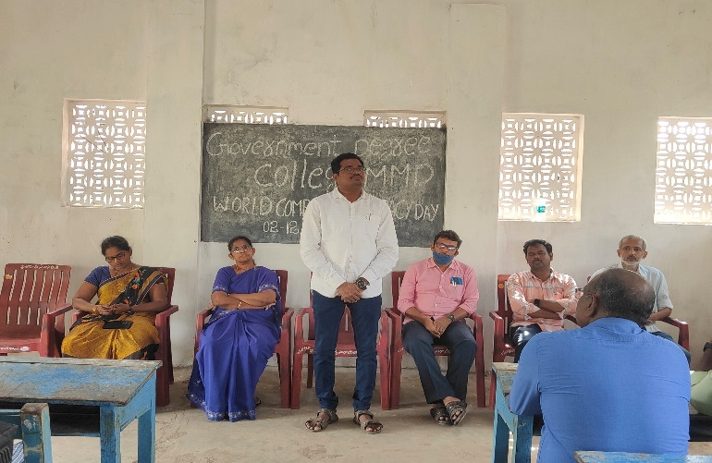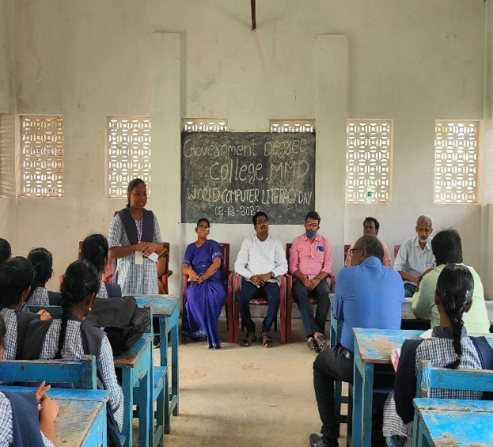
Awareness Program on World Computer Literacy Day to all the three-years Students.

Signature of the Principal Signature of the Lecturer

